John Cosentino

Nick Raynin

CSC 330

Project 2: Newspaper Delivery System

**User Guide**

1. Log-in and Verification  
   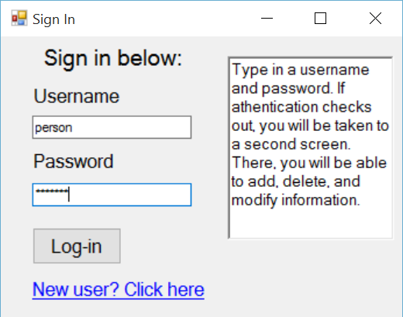  
   Simply type in your username in the Username box, and type in your password in the Password box. The information in both boxes is case sensitive.
2. Register a new user  
   Click on the link “New user? Click here”, highlighted in red.  
   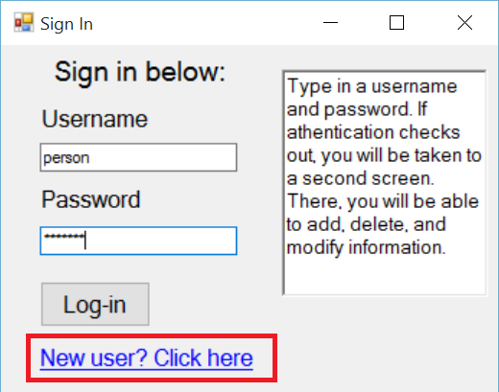  
   Below is the registration screen:

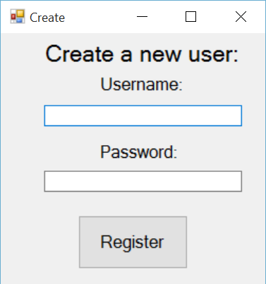  
Duplicate usernames are **not** allowed. Both fields are sensitive

1. Searching the database  
   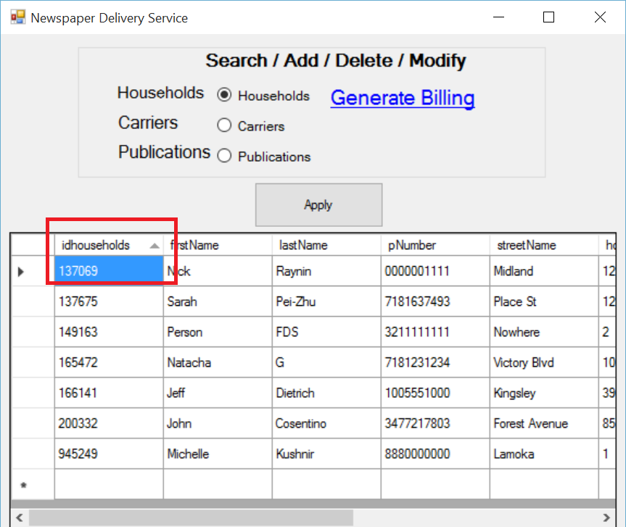  
   Searching the database is easy. Simply select one of the radio buttons to search the households, carriers, or publications. In order to sort a row, click on the title of the row. Highlighted in red is an example of the sort.
2. Adding to the database  
   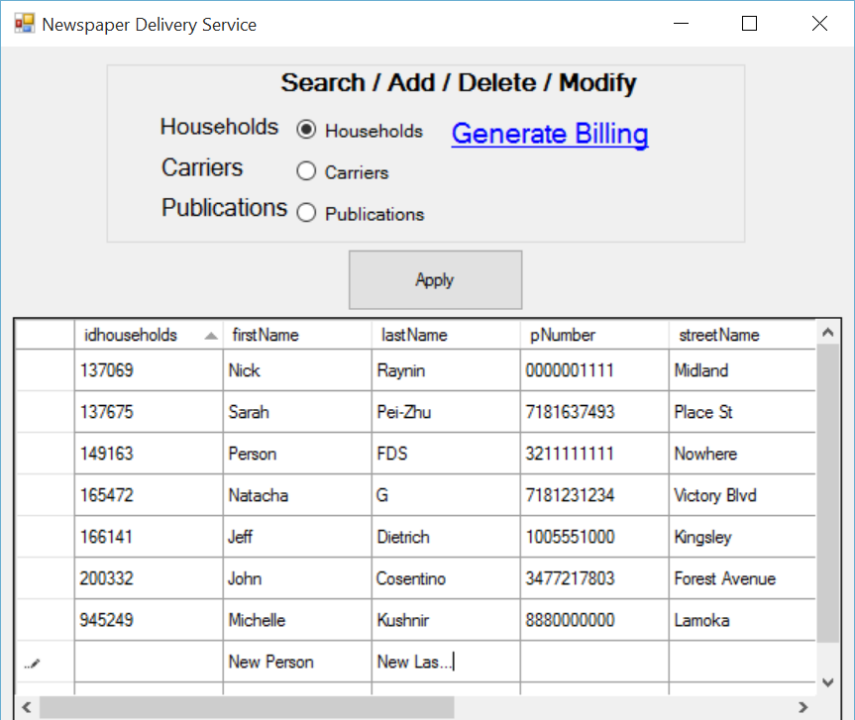  
   Adding to the database simply involved clicking into a row, and typing. After typing in the appropriate information, just press Enter twice. This message will appear once the information has been added:  
   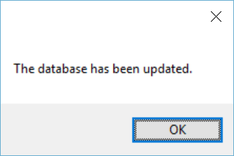  
   The IDs are automatically generated:  
   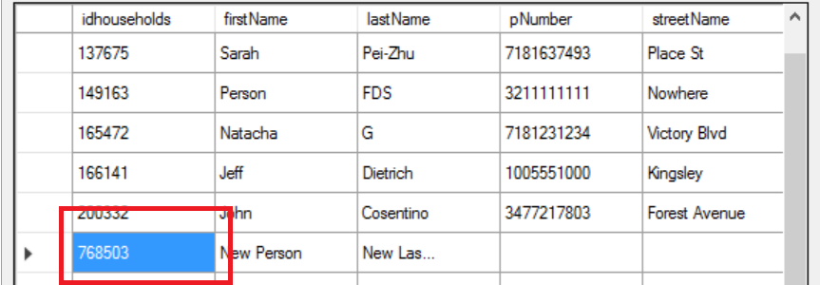
3. Deleting from the database  
   Simply highlight the row, deleted, and press Enter twice.  
   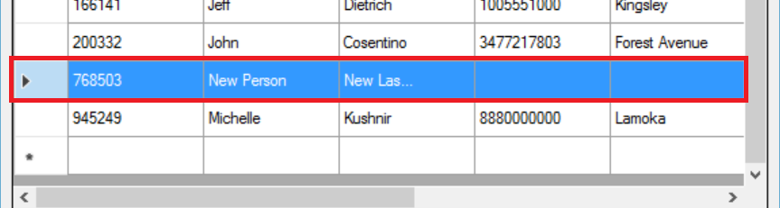  
   This will be confirmed:  
   
4. Modifying the database
   1. Special case: Carriers  
      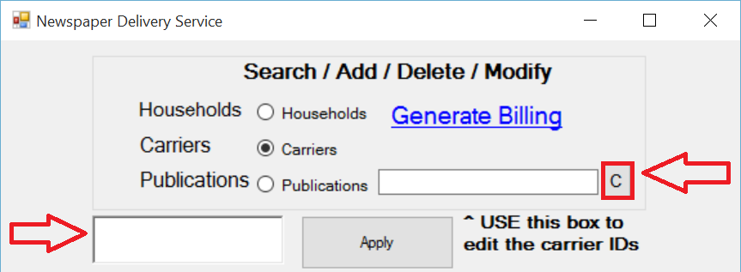  
      The IDs within Carriers must be edited. In order to do so, type in the appropriate ID into the text box on the right. When the button says ‘C’, this is the carrier ID. When the button denotes ‘H’, this is for the household ID. When it denotes ‘P’, this is for publication ID.  
      The left arrow points to a textbox, which is used as a notepad.
5. Copying cells  
   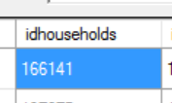  
   Copying is as simple as selecting the cell and copying via event handler (such as Ctrl+C).
6. Generating the household billing  
   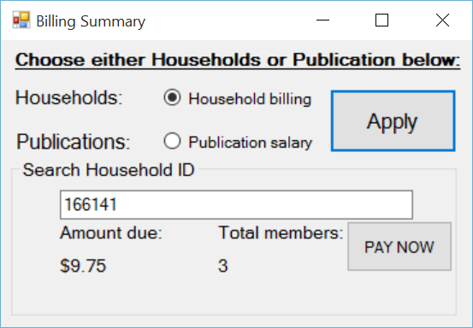  
   Simply type in the appropriate household ID and click apply.  
   Click PAY NOW to pay your bill.  
   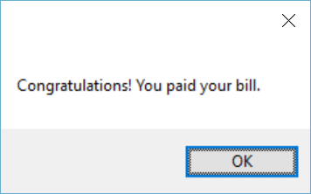
7. Generating the publication salary  
   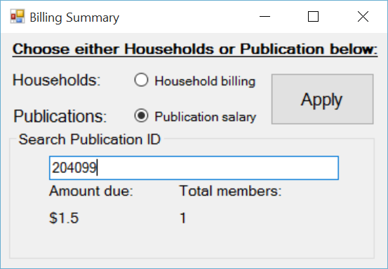  
   Publication salary can be generated using the appropriate publication ID.
8. Credits  
   Project by John Cosentino & Nick Raynin